**INTRODUCTION**

**Chapter 1**

**Introduction**

* 1. **Definition**

e-Library is a user-friendly online application that delivers general reference collections of books and digital media content designed to support every range of user, including elementary users, college students and college-level researchers, and professional educators.

**e-Library** is an online resource offering endless reading pleasure and learning opportunities through e-books. Our books can be read online on a laptop, home computer or accessed via tablets and smartphones utilising the user-friendly application. It provides a login interface to the users. Using e-Library user can send messages to their friends, view book issue status, read e-Books , request for book issuance, etc.

It involves all facilities such as library book status, review book , recommend book and a social platform through which users can share books with each other, etc. It can be run using a local server like Apache Tomcat or by hosting it as a website. The project is having different modules like new User creation form named it as a Sign-Up form and already existing user can logged into e-Library named it as a Sign In form. It also implements library management facilities that can be used by a educational institute, central libraries, etc.

* 1. **Objective**

The main objective of developing this project is to provide digital learning experience to a variety of audience including college graduates, working professionals and teacher, etc. The goal is to provide all library facilities in one software. It provides a login –logout facility to the users through which they can easily get in touch of their library book details and can also read books online.

* 1. **Scope**

The scope is global i.e. it can be used by any educational institution for library management, central Libraries, etc. Any institute can use e-Library to provide online learning facility to its users by using this application.

* 1. **Advantages**

The first and foremost advantage is that by using this application is-now the users do not need to come all the way from home to library for library book issuance. They can request for book issue from their home.

The user of e-Library is given a unique login id and must give the correct password. So unauthorized user can't see user’s profile, personal information, etc. Even if the user forgets his/her password reminding facility by which the user can recollect the password and log into the system.

The advantage of the this system is it's security feature allowing only registered users to access the system and preventing any hackers, unauthorized users.

* 1. **Limitations**

The limitation of e-Library is that it can not be run without internet connection. It is an online application it either requires a local server to run or can be run by hosting . It can not be run as a desktop application.

**DETAILED**

**DESCRIPTION**

**Chapter 2**

**Detailed Description**

* 1. **Project Description**

**e-Library** is an online resource offering endless reading pleasure and learning opportunities through e-books. Apart from this it also provides library management facility that can be used by Central Libraries, educational institutes, etc. There are two types of entities associates with this web application:

1. User i.e Users
2. Administrator

A user or a user can register itself and once get registered he/she can easily login to e-Library with the help authenticated password.

A user is associated with the following tasks:

1. Register itself to E-Library
2. Login or Logout to their account
3. View profile
4. Read books, add/delete books to its account.
5. Request for book issuance, etc.

While the administrator is responsible for following tasks:

1. Update users profiles
2. Upload syllabus ,timetable and results
3. Create and delete users
4. View all registered users.
   1. **Project Features**

Following are the major project features:

1. It is all in one software which consists of all the facilities in one module.
2. Can be extended further by adding new features.
3. Provides high security features by efficient verification and validation.
4. Contains features like save password, forgot password and password recovery which makes it flexible.
5. Can be used at different levels by different users.
6. Includes social platform to share books, recommend books, etc.

**REQUIREMENT SPECIFICATION**

**Chapter 3**

**Requirement Specification**

Requirement analysis for web applications encompasses three major tasks: formulation, requirements gathering and analysis modeling. During formulation, the basic motivation and goals for the web application are identified, and the categories of users are defined. In the requirements gathering phase, the content and functional requirements are listed and interaction scenarios written from end-user’s point-of-view are developed.

**3.1 Hardware Requirements**

The collection of internal electronic circuits and external physical devices used in building a computer is called the Hardware. The minimum hardware requirement specifications for developing this project are as follows:

**Processor : Standard processor with a speed of 1.6 GHz or more**

**RAM : 256 MB RAM or more**

**Hard Disk : 20 GB or more**

**Monitor : Standard color monitor**

**Network : LAN or Wireless card required**

**3.2 Software Requirements**

A set of programs associated with the operation of a computer is called software. Software is the part of the computer system, which enables the user to interact with several physical hardware devices.

The minimum software requirement specifications for developing this project are as follows:

**Operating System : Window 2000, XP,Win 7,Win 8.**

**Presentation layer : Java, Servlets.**

**Database : Oracle**

**Documentation Tool : Ms Office**

**Server Software : Apache Tomcat**

**Browser : Google Chrome/Mozilla Firefox/IE**

**3.3 Functional Requirements**

The functional requirements for a system describe what the system should do. These requirements depend on the type of software being developed, the expected users of the software, and the general approach taken by the organization when writing requirements. When expressed as user requirements, functional requirements are usually described in an abstract way that can be understood by system users. However, more specific functional system requirements describe the system functions, its inputs and outputs, exceptions, etc., in detail.

These are statements of services the system should provide, how the system should react to particular inputs, and how the system behave on in certain situations.

**Functional Requirement:**

From user point of view:

1. Register
2. Login and logout facility
3. Update and delete information
4. Add/Delete e-Books
5. Read e-Books
6. Search book
7. Check book issue status, request for book issue, etc.
8. Recommend, review books, etc.

From Admin point of view:

1. Create and delete users
2. Modify user information
3. Book issuance and submission
4. Upload new books
5. View and modify book details
6. Add/delete books, increase/decrease book count, etc.

**SOFTWARE ENGINEERING PARADIGM**

**Chapter 4**

**Software Engineering Paradigm**

The software industry includes many different processes, for example, analysis, development, maintenance and publication of software. This industry also includes software services, such as training, documentation, and consulting.

These different requirements and needs give us various software development approaches to choose from during software implementation

**SDLC** is a process followed for a software project, within a software organization. It consists of a detailed plan describing how to develop, maintain, replace and alter or enhance specific software. The life cycle defines a methodology for improving the quality of software and the overall development process.

**Spiral Model**

Spiral model is an evolutionary life cycle model. It combines the feature of iterative model and waterfall model.

In Spiral model , a project is developed as a series of incremental release. There are various phases involved in spiral model. Here a project is developed in a series of iterations. Each phase of the model is denoted by loop in the diagrammatic representation.

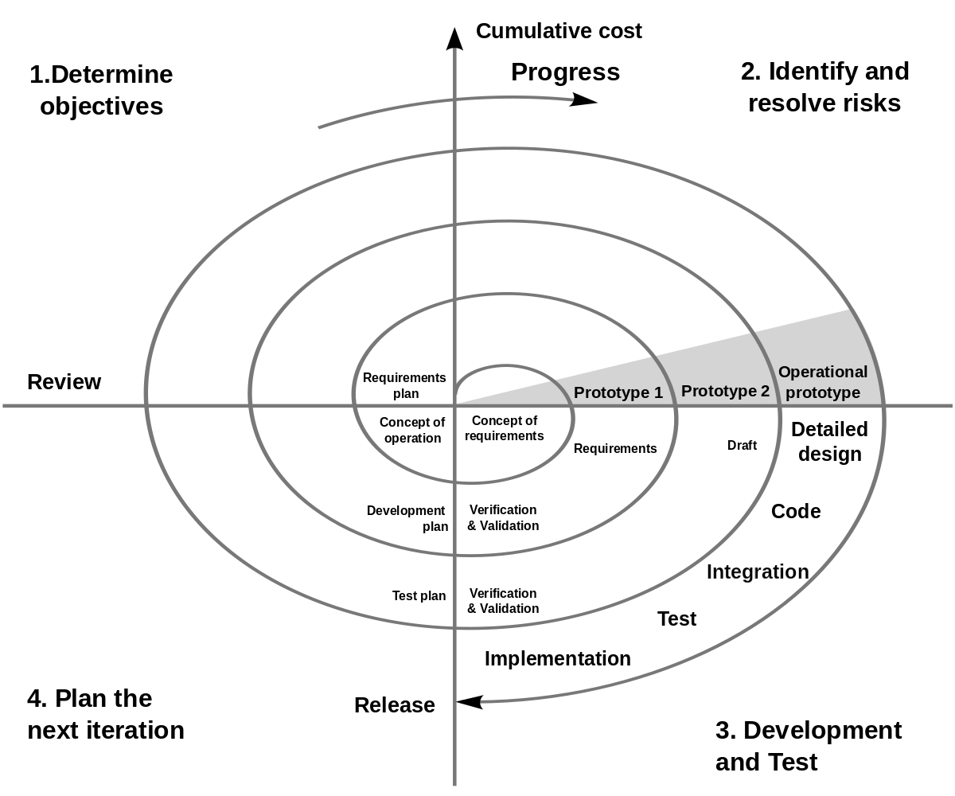

Each iteration of spiral model consist of following tasks:

1. **Determine Objectives**
2. **Identify and resolve risks**
3. **Development and Testing**
4. **Customer evaluation**
5. **Customer Feedback**
6. **Planning the next iteration**

**TECHNOLOGY USED**

**Chapter 5**

**Technology Used**

* 1. **JDK 1.7**

JDK stands for Java Development Kit.

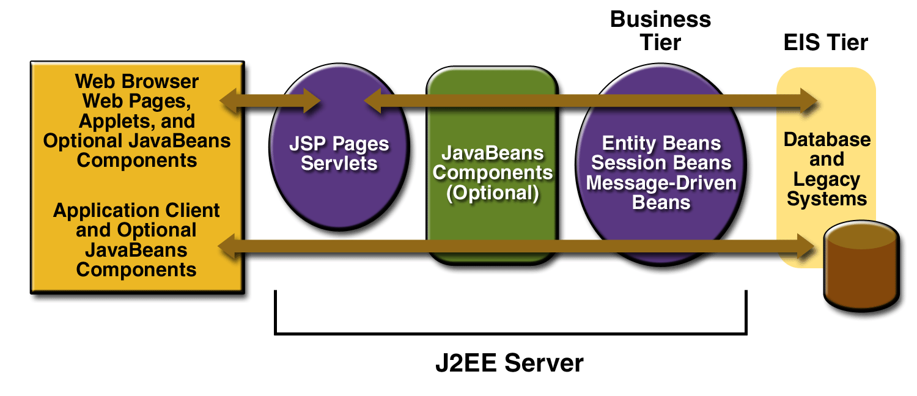

* 1. **Servlets and JSP**

A servlet is a java programming language API that is used to extend the capabilities of servers that host applications access via a request-response programming mode. Servlets are Java technology’s answer to Common Gateway Interface (CGI) Programming.

Java Server Pages technology is the Java platform technology for building applications containing dynamic Web content such as HTML, DHTML and XML. The Java Server Pages technology enables the authoring of Web pages that create dynamic content easily but with maximum power and flexibility

* 1. **Oracle 10g Express Edition**

Oracle 10g is Oracle’s Database server which provides storage of data in form Tables. We used JDBC API (Java Database Connectivity) to connect with Oracle 10g database. In oracle database we can easily create and manipulate tables and their data using sql or plsql commands.

* 1. **Apache Tomacat 7.0.2**

Apache Tomcat is the servlet container that is used in the official Reference Implementation for the Java Servlet and Java Server Pages technologies. The Java Servlet and Java Server Pages specifications are developed by Sun under the Java Community Process.

Tomcat 7.0.2 implements the Servlet 2.4 and Java Server Pages 2.0 specifications and includes many additional features that make it a useful platform for developing and deploying web applications and web services.

**Front End :**

1. **HTML**
2. **CSS**
3. **JavaScript**

**Back End :**

1. **Servlet**
2. **JSP**
3. **Oracle 10g(Database) using Jdbc API**

**SYSTEM DESIGN**

**AND**

**ANALYSIS**

**Chapter 6**

**System Design And Analysis**

**6.1 E-R Diagram**

An E-R Diagram is entity-relaltionship diagram which shows the different entities with their attributes and relationship between the entities.

**Entity:**

**Attributes:**

**Relationship:**

BOOKS

PUBLISHER

PUBLISHER

USER

BORROWED bbBYBY

**6.2 Data Flow Diagram**

A **data flow diagram** (**DFD**) is a graphical representation of the "flow" of data through an [information system](http://en.wikipedia.org/wiki/Information_system), modeling its *process* aspects. Often they are a preliminary step used to create an overview of the system which can later be elaborated. DFDs can also be used for the [visualization](http://en.wikipedia.org/wiki/Data_visualization) of data processing (structured design).

**DFD for Admin**

View user details

Username, Password

ADMIN

Registration details

User Management

Book Management

Add Solutions, Books

**DFD for User**

Verify

Read

Username,Password

Register user

Login

Share ,Review

bo

Username/Password

USER

**6.3 Use Case Diagram**

* A use case diagram is a diagram that shows a set of use cases and actors and relationships.

**Contents**

* Use case commonly contain
* Use cases
* Actors
* Dependency, generalization and association relationships

**Admin**

**Admin Use Case Diagram**

**User**

**User Use Case Diagram**

**DATABASE TABLES**

**Chapter 7**

**Database Tables**

**Oracle Database Tables**

The following database tables are used for implementing the application:

1. e-Libraryuser
2. e-Librarybooks
3. e-Librarybookissuerequest
4. e-Libraryuserbooks
5. e-Librayfriendship
6. e-Librarymail
7. e-Librarybookreview
8. e-Libraryrecommendbook
9. e-Libraryauthor
10. e-Libraryfriendrequest

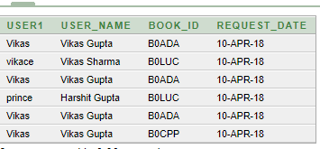

**elibrarybookissuerequest Table**

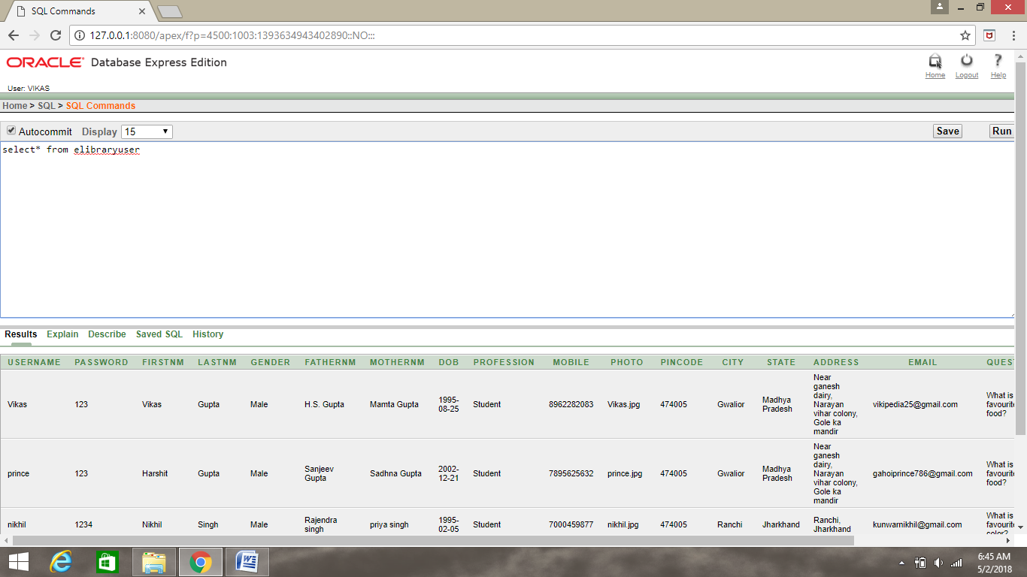

**elibraryuser Table**

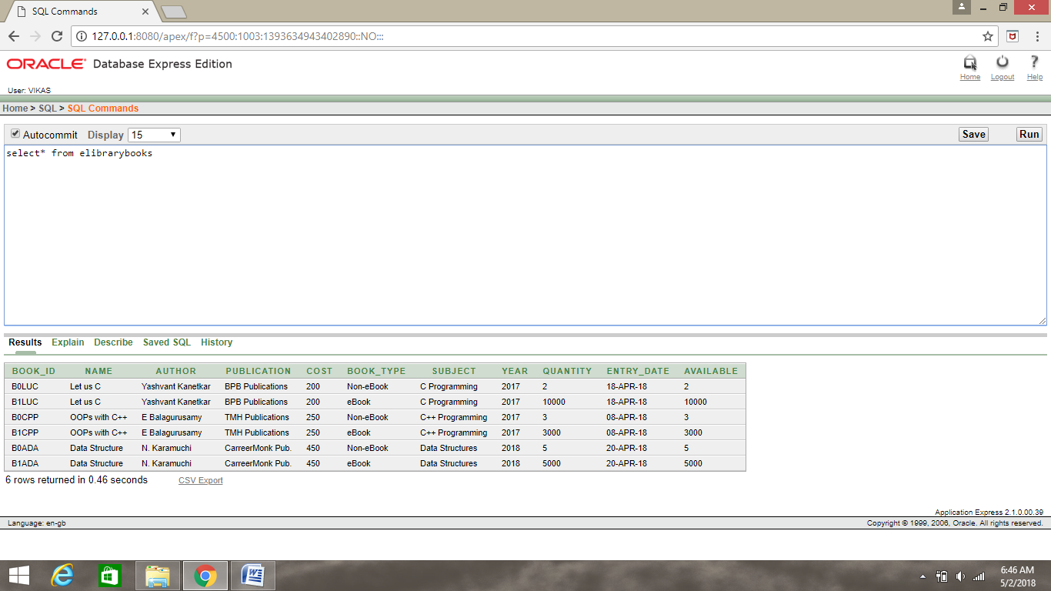

**elibraybooks table**

**MODULE SNAPSHOTS**

**Chapter 8**

**Module Snapshots**

**Home Page**

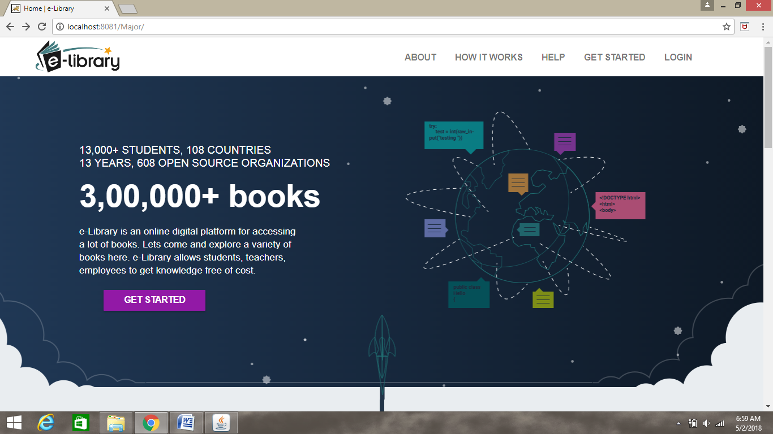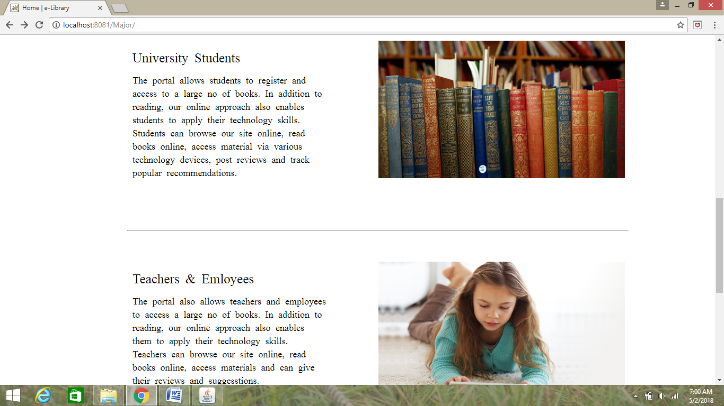

**Login Page**

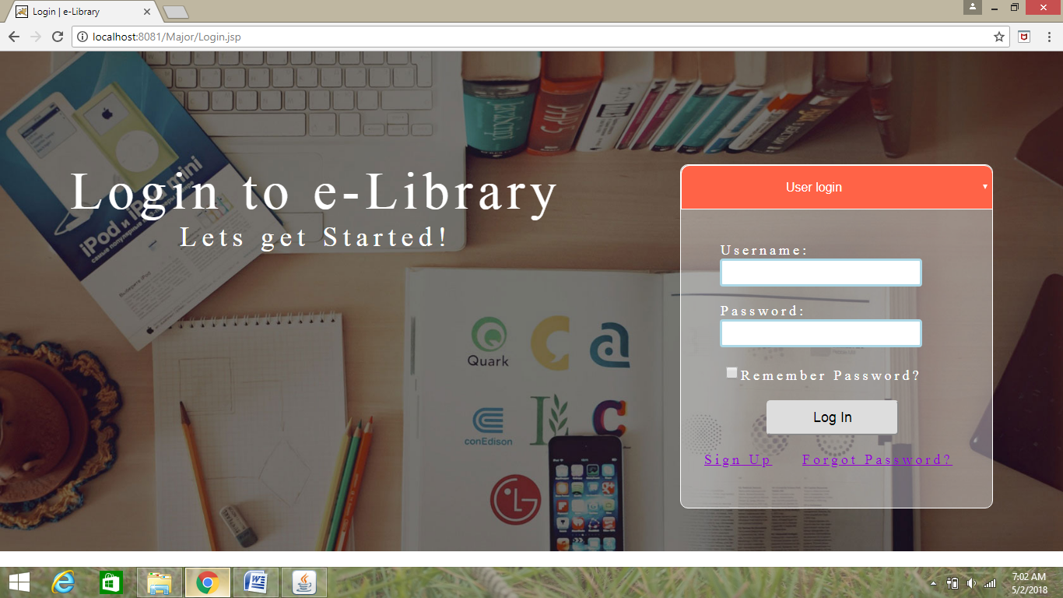

**Registration Page**

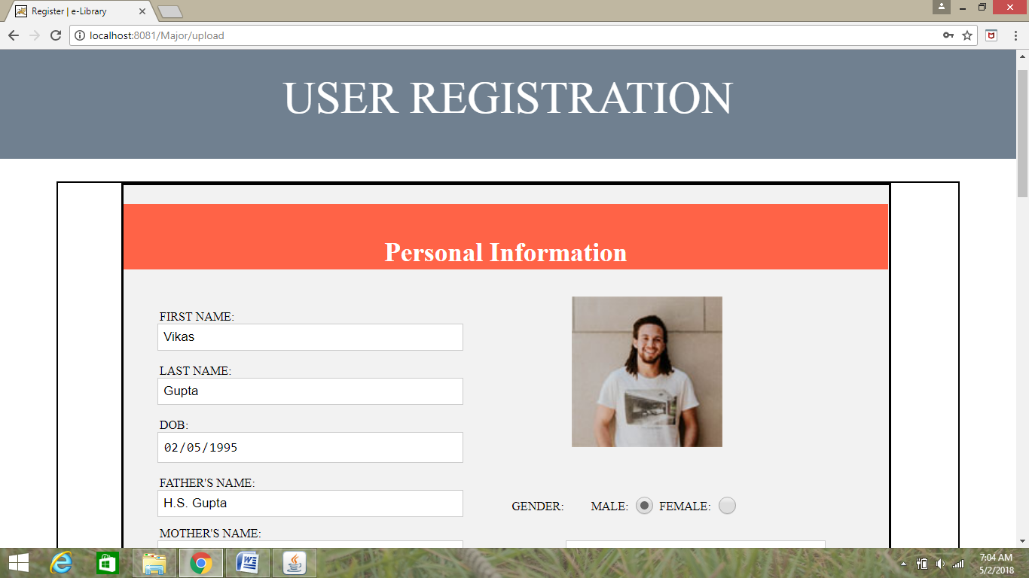

**User Login**

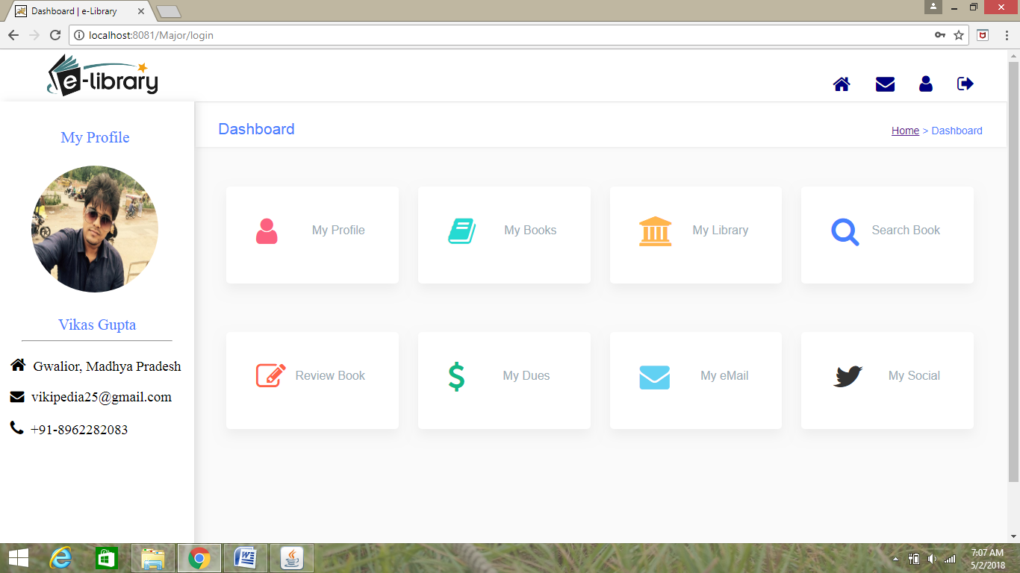 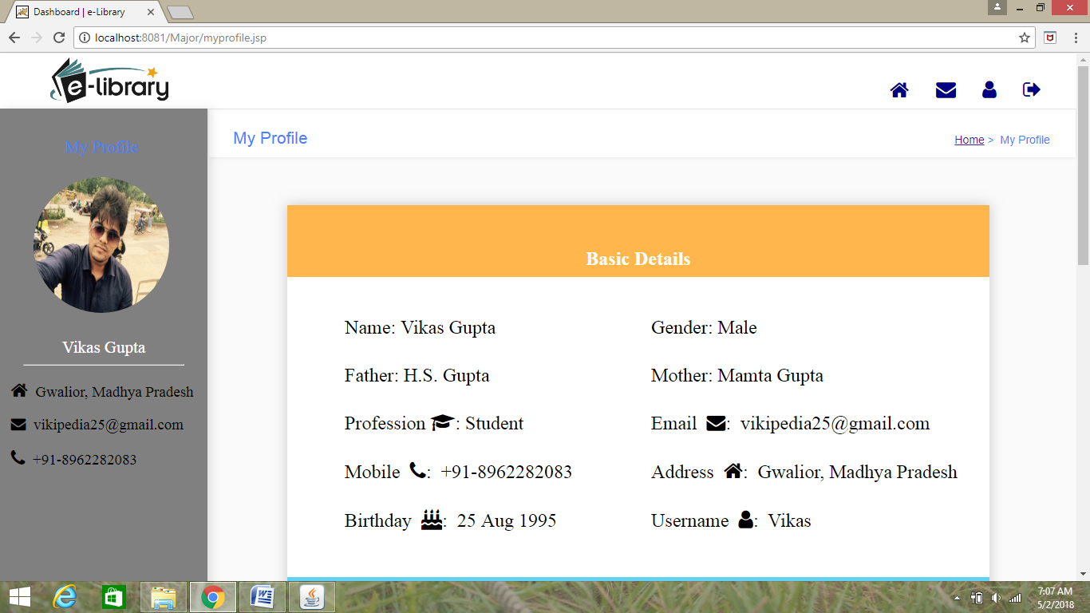

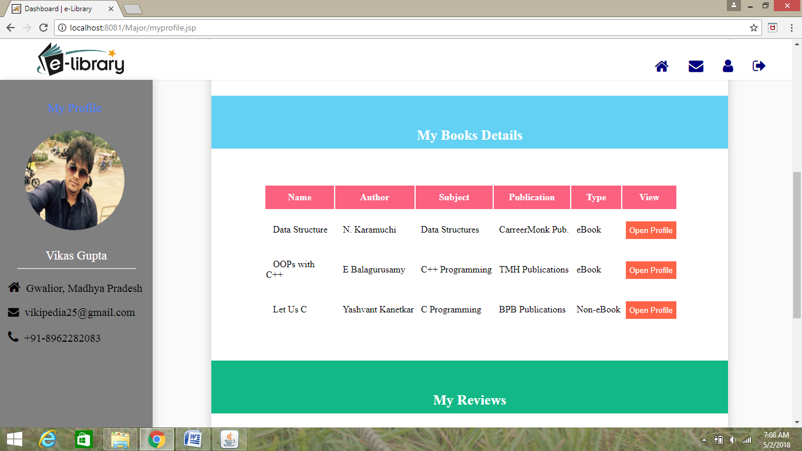

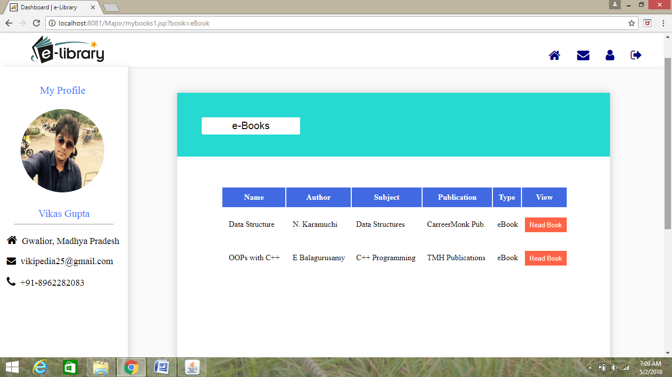

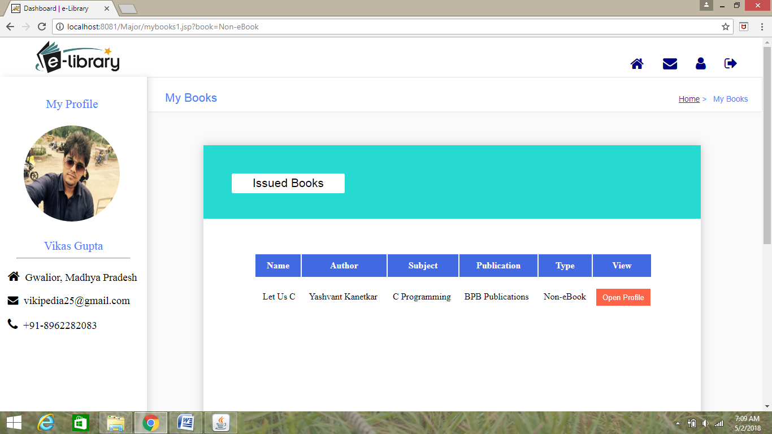 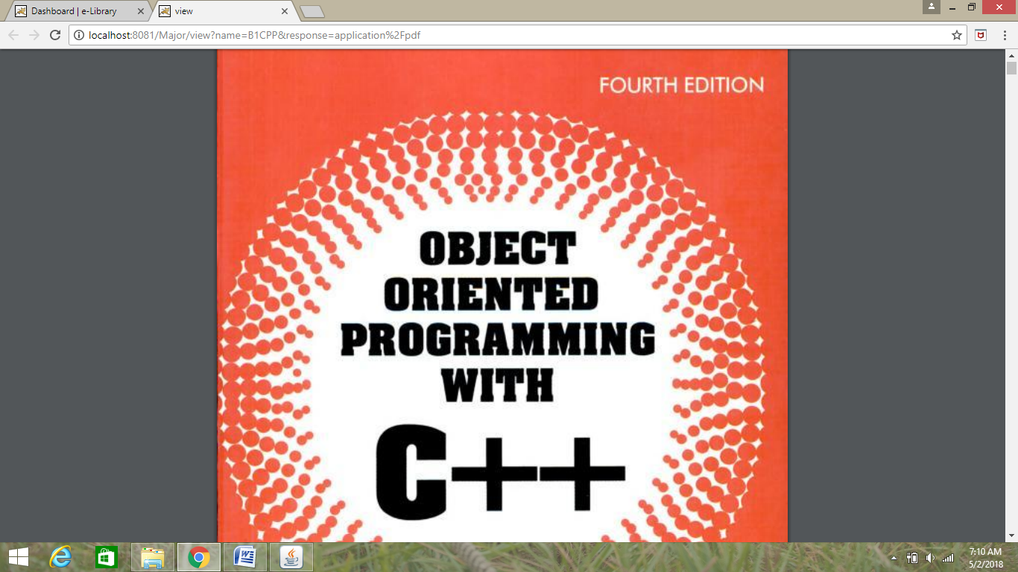

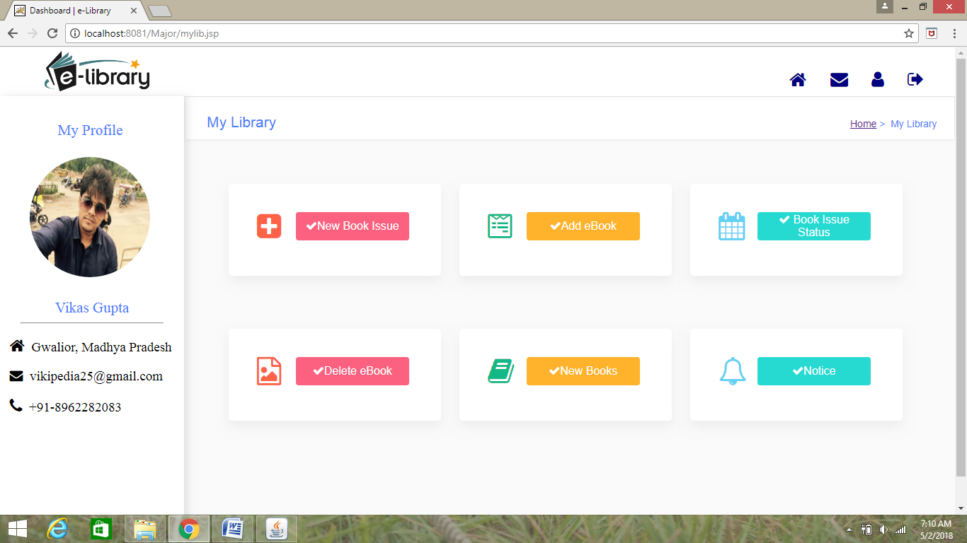 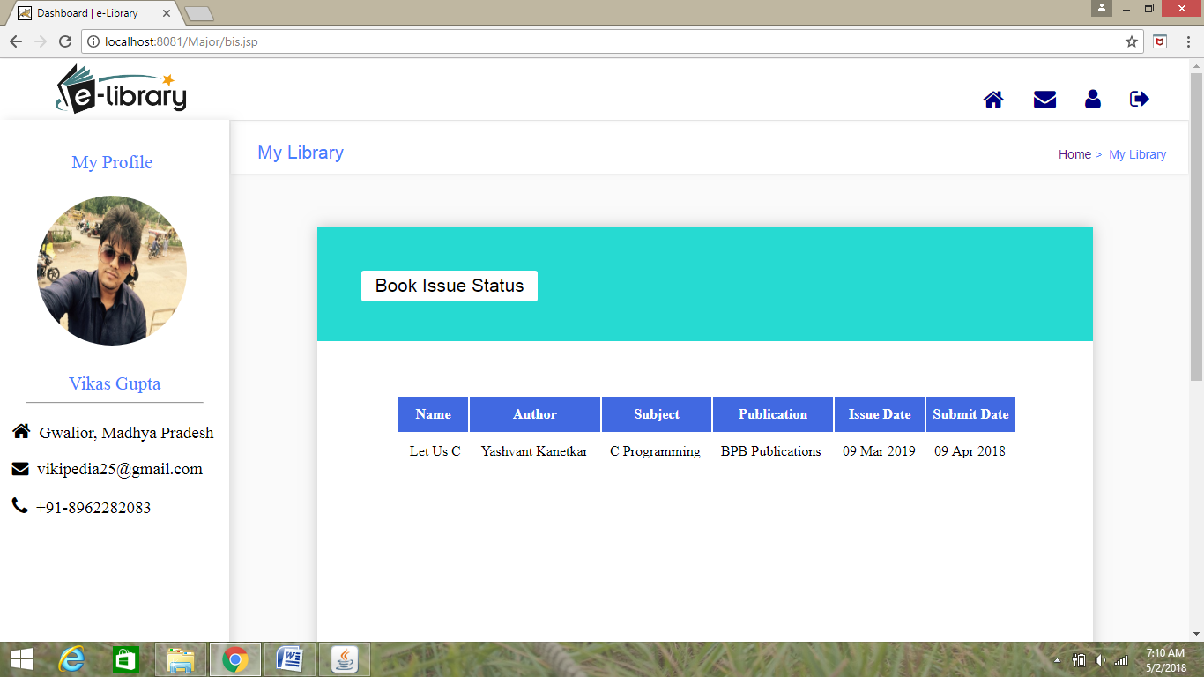

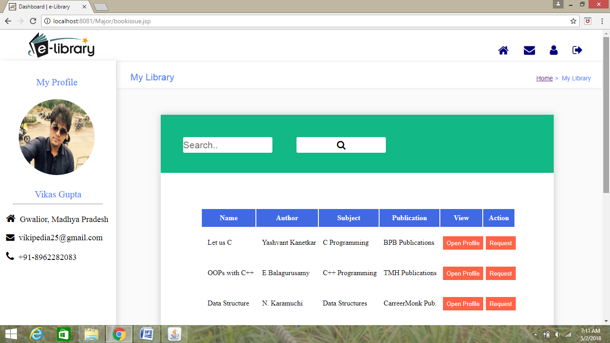 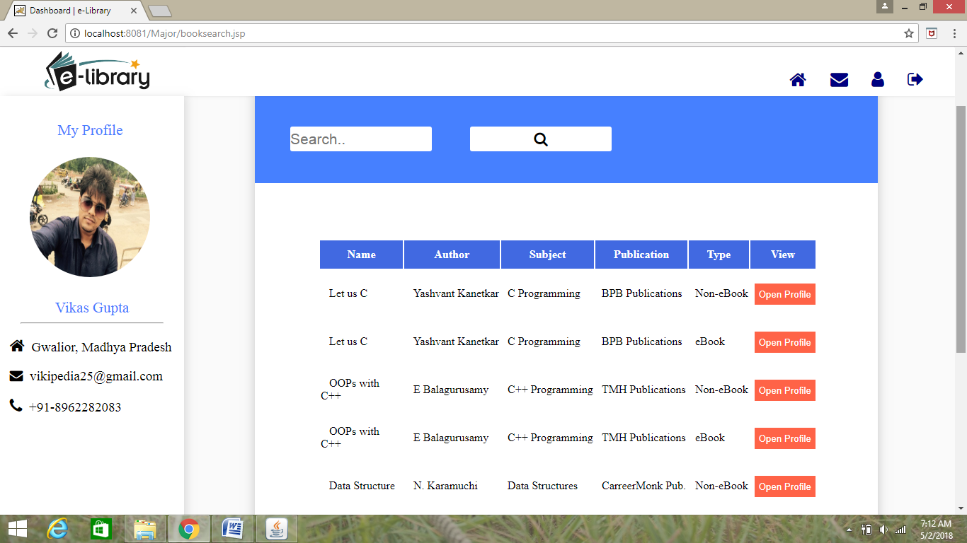

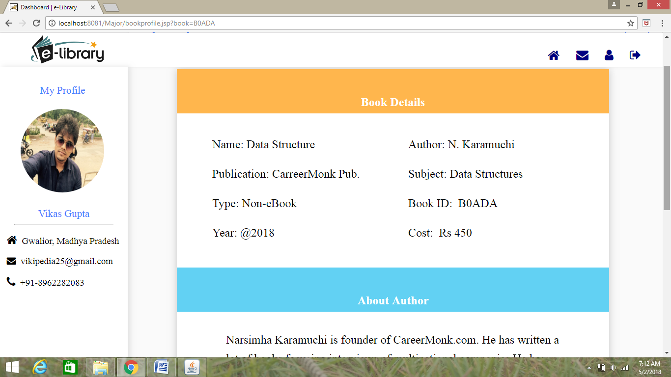 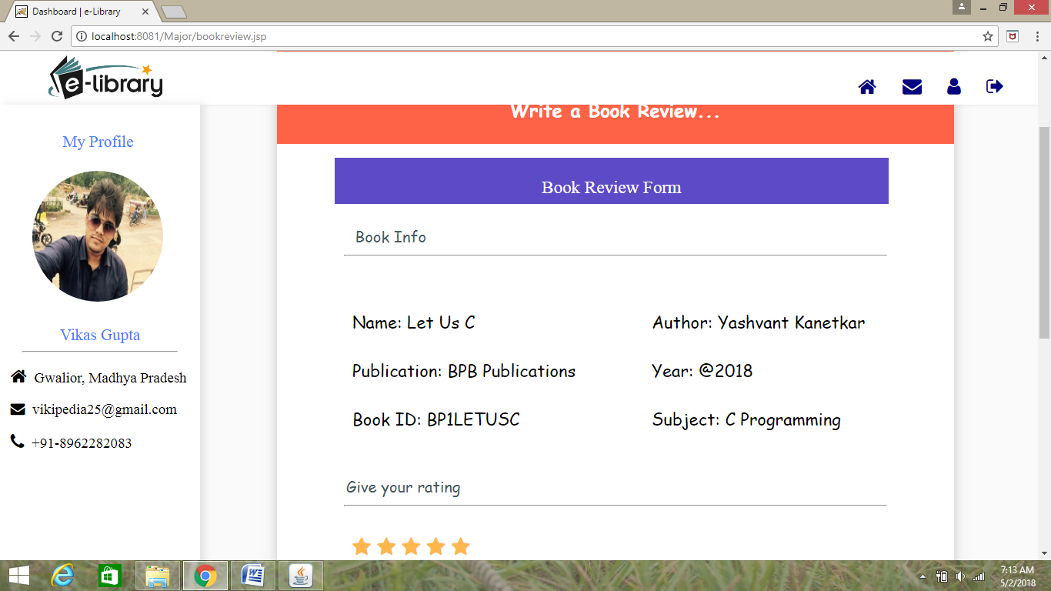

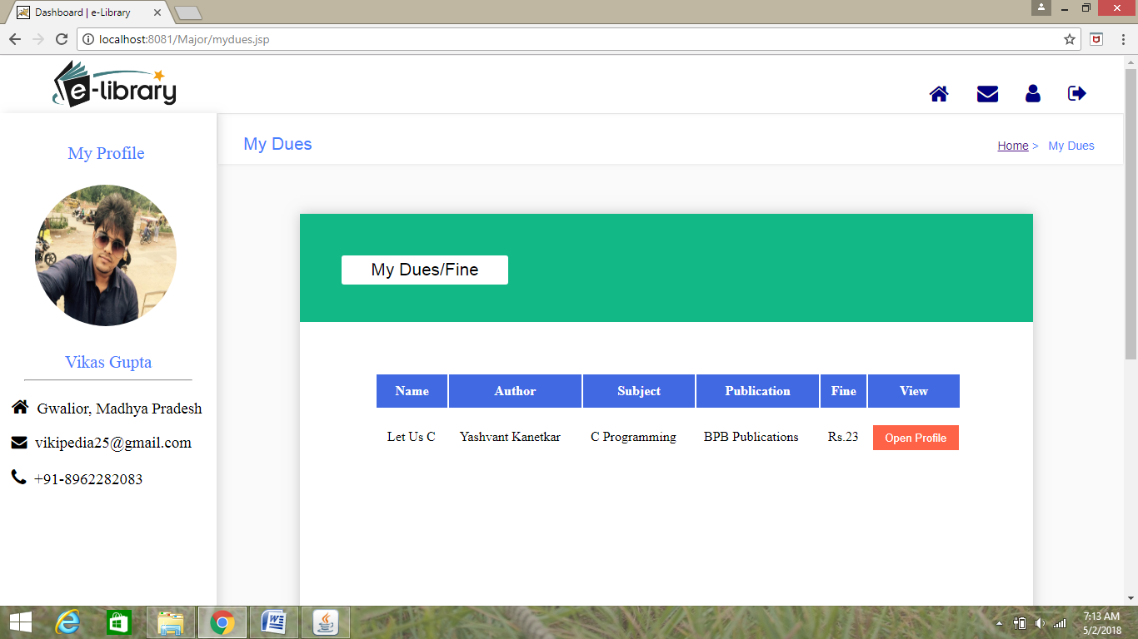 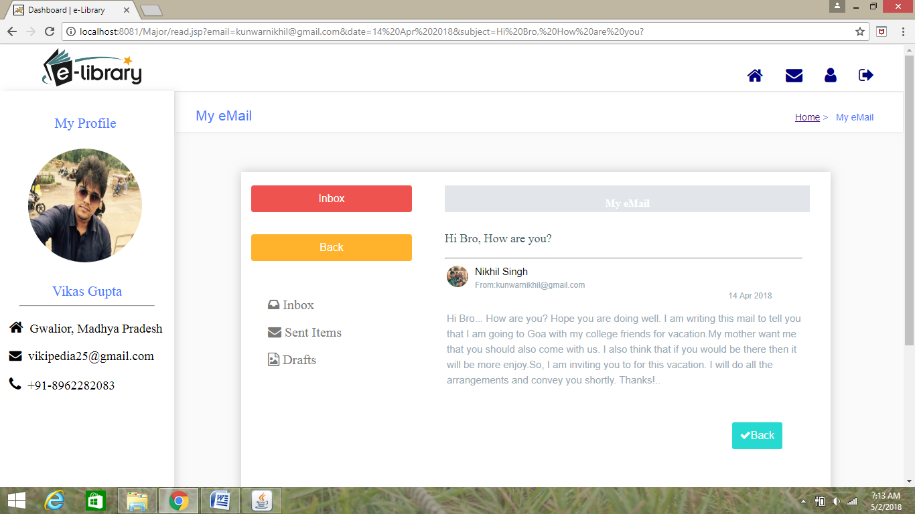

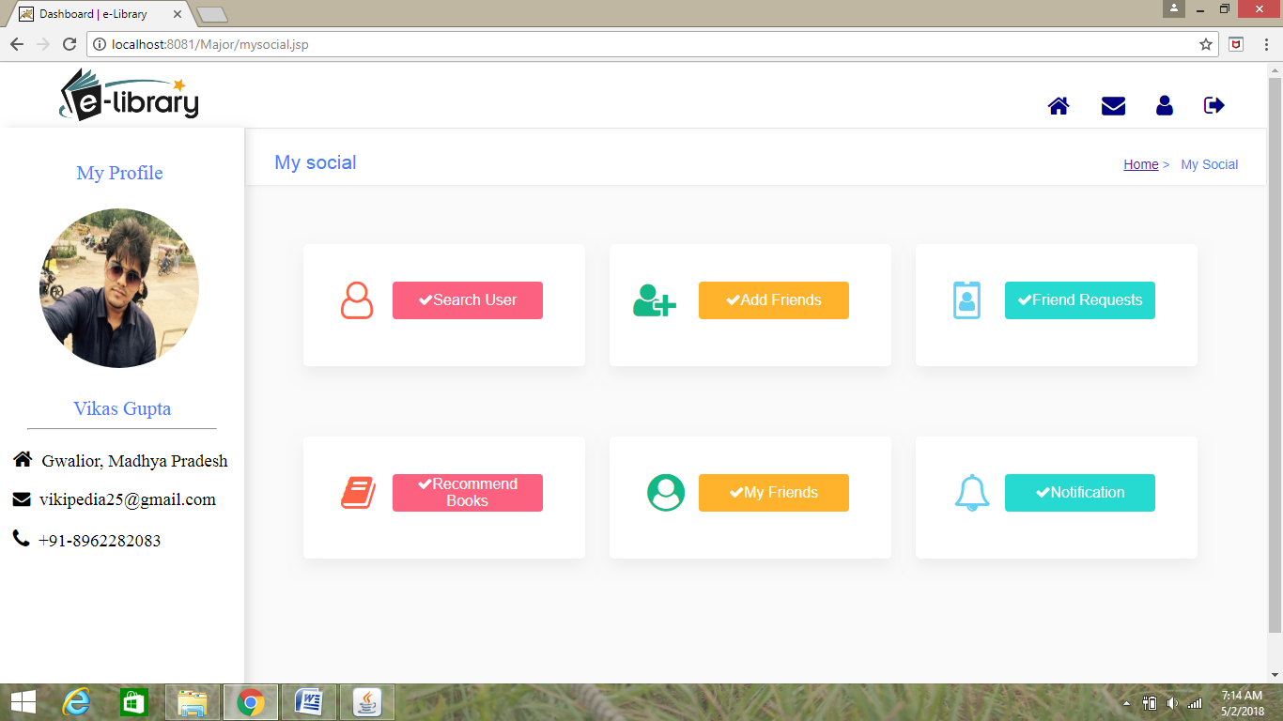

**Admin Login**

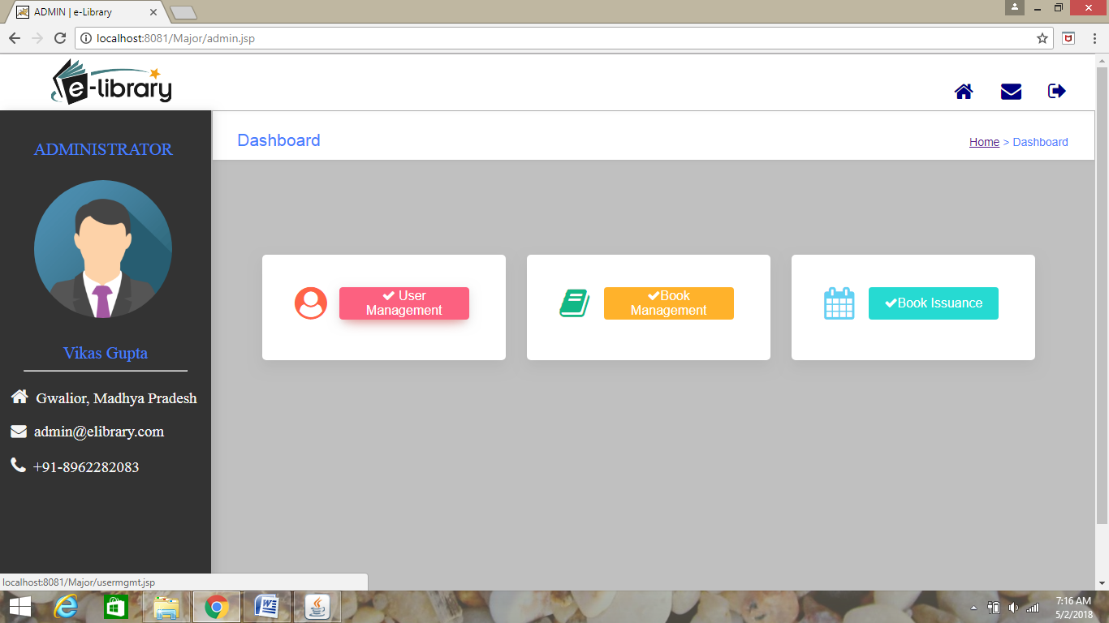

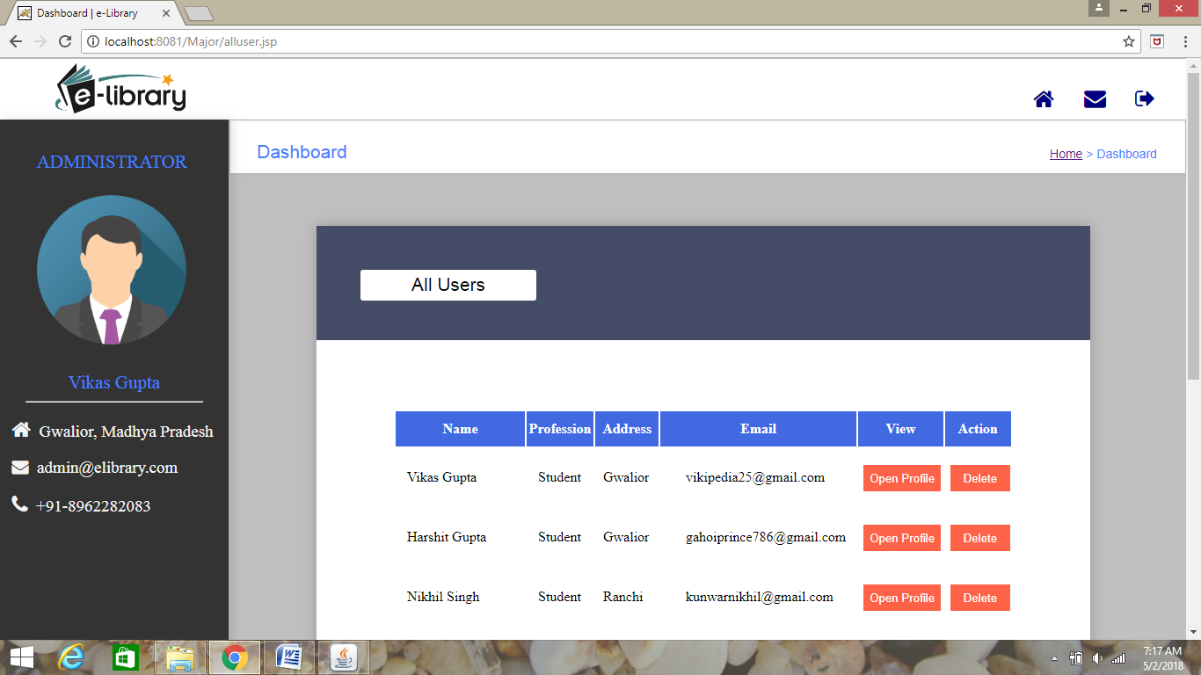

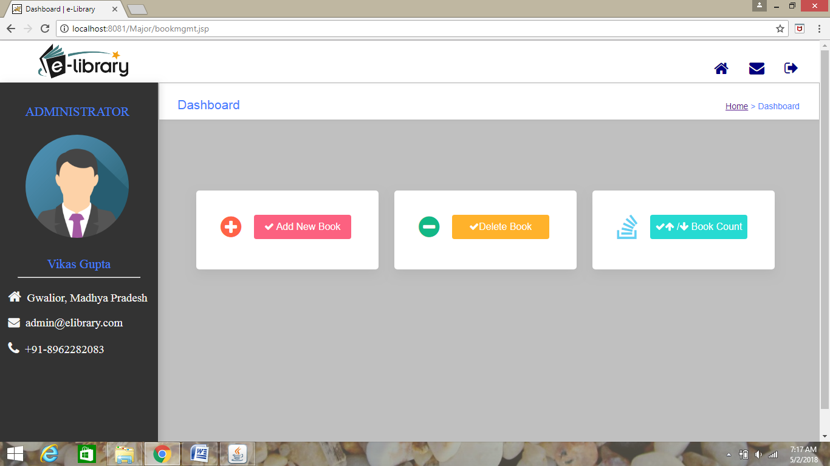

**CODING AND TESTING**

**Chapter 9**

**Coding And Testing**

**9.1 Coding**

**Module Arrangement**

The structural implementation of the web application as follows:

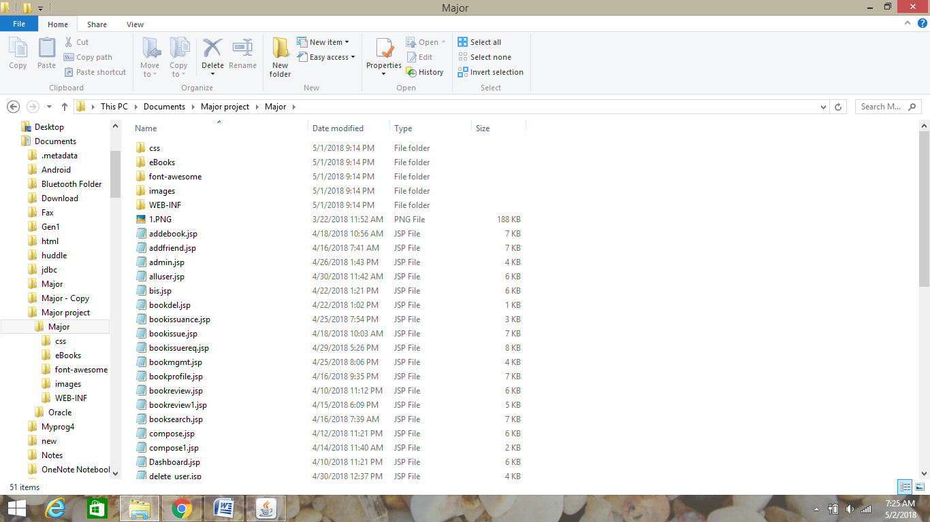

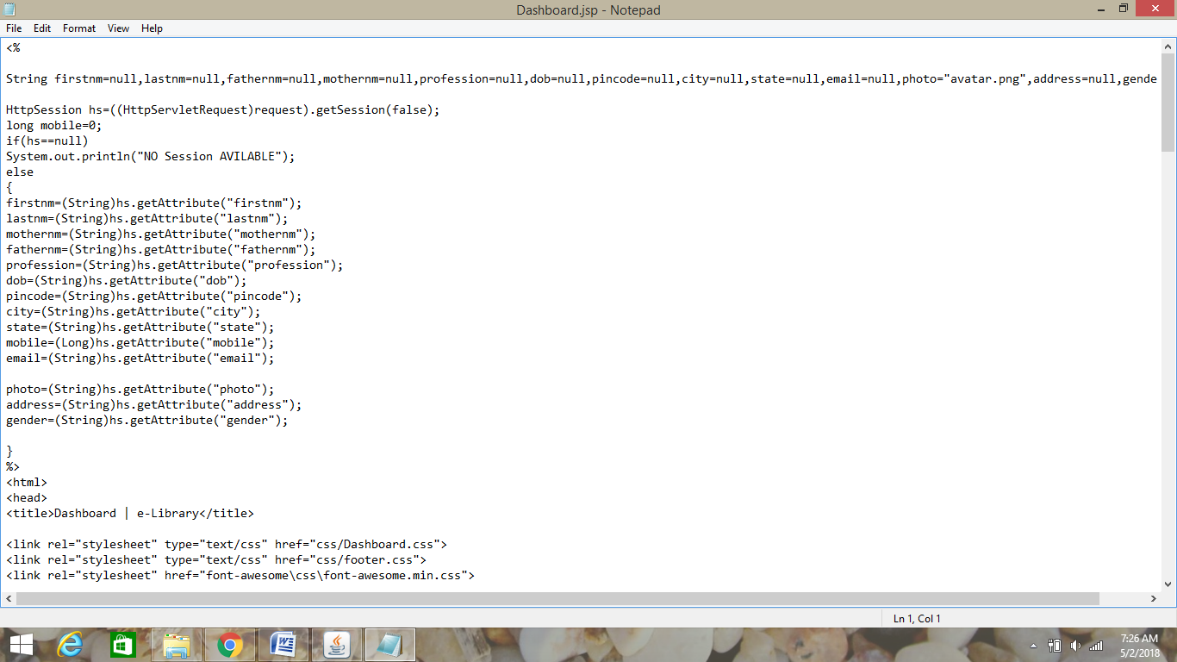

Other coding snippets are provided in CD.

**9.2 Testing**

Software testing is a critical element of software quality assurance and represents the ultimate review of specification, design and coding.

A strategy for software testing integrates software test case design methods into a well-planned series of steps that result in the successful construction of software. Testing is the set of activities that can be planned in advance and conducted systematically.

UNIT TESTING

MODULE TESTING

SUB-SYSTEM TESING

SYSTEM TESTING

ACCEPTANCE TESTING

Component Testing

Testing

Integration Testing

UserTesting

The entire testing process can be divided into 3 phases

1. Unit Testing

2. Integrated Testing

3. Final/ System testing

**UNIT TESTING**

In our system, Unit testing is performed on each module to check the correct and accurate working. The test data was given to each and every module in all respects and got the desired output. Each module has been tested found working properly.

**INTEGRATION TESTING**

Test data should be prepared carefully since the data only determines the efficiency and accuracy of the system. Artificial data are prepared solely for testing. Every program validates the input data.

**VALIDATION TESTING**

In this, all the Code Modules were tested individually one after the other. The following were tested in all the modules

1. Loop testing

2. Boundary Value analysis

3. Equivalence Partitioning Testing

**SYSTEM TESTING**

This is the final step in testing. In this the entire system was tested as a whole with all forms, code, modules and class modules. This form of

It involves:

* **Alpha Testing:** It is a type of user acceptance testing, which is conducted on an application when it is just before released to the customer.
* **Beta-Testing:** It is a type of UAT that is conducted on an application when it is released to the customer, when deployed in to the real time environment and being accessed by the real time users.
* **Acceptance Testing:** It is carries out by the user or customer to determine whether to accept or reject the software delivered.

**CONCLUSION**

**AND**

**FUTURE PROSPECTS**

**Chapter 10**

**Conclusion and Future Prospects**

The website (e-Library) enables a user to have easy access to all the library books online. Through this website, the users no longer need to come all the way from their home to the library for issuing book and to wait in long queues .They can easily request for book issuance from their home and collect the book from library. User can also read a large no of books available online as e-Books.

Now due to this website, users can even stay in touch with their friends, can message them, share and recommend books to their friends. A user just need to visit over this website using any browses like Google Chrome, Firefox, Opera etc. and can access all the benefits of the website.

**BIBLIOGRAPHY**

**AND**

**REFERENCES**

**Chapter 11**

**Bibliography and References**

* **For Java installation**
  + - https://www.java.com/en/download/
* **For Oracle DataBase installation**
  + - <http://www.oracle.com/index.html>
* **Reference websites**
  + - [www.javatpoint.com](http://www.javatpoint.com)
    - [www.w3schools.com](http://www.w3schools.com)
    - [www.codesadhna.com](http://www.codesadhna.com)
    - [www.google.com](http://www.google.com)
* **Reference Books**
  + - Thinking in java
    - OCJP Certified Programmer for Java
    - Learn Java in Easy Steps